

Mini Project Report – 15

Bachelor of Computer Application
Semester – IV

Sub : Full Stack Development

Topic: MongoDB Report
By
Name: MUHAMMED FAIZ C K
Reg no.: 2411021240042

Faculty Name: VEERA RAGHAV K

Faculty Signature: _______________

Department of Computer Application
Alliance University
Chandapura – Anekal Main Road, Anekal
Bengaluru – 562 106

Introduction to MongoDB
MongoDB (MDB) is a popular NoSQL database used to store and manage data in a simple and flexible way. Unlike traditional databases that use tables and rows, MongoDB stores data as documents. These documents look like JSON objects and contain key-value pairs. This makes the data easy to read and understand. Developers can also change the structure of documents without changing the whole database design.
MongoDB is useful for modern applications such as websites, mobile apps, and cloud services. It can handle large amounts of data and works well when data changes often. Because it is schema-flexible, you do not need to define all fields in advance. This saves time during development and testing.
MongoDB also provides important features like indexing for faster search, replication for backup and reliability, and sharding to spread data across many servers. These features help applications run quickly and stay available even if one server fails.
It supports many programming languages such as JavaScript, Python, Java, and C#. MongoDB uses a query language that is simple and powerful. Overall, MongoDB is a good choice for developers who need a fast, scalable, and easy-to-use database system for real-world applications.

REQUIREMENTS: MongoDB Community Server & MongoDB Compass
Differences & Use Cases
Key Differences:
-Data Model
MongoDB: Document-oriented, stores data in JSON-like BSON format.
Relational DB: Table-based with rows and columns.
Schema
MongoDB: Schema-less, flexible — documents can have varying fields.
Relational DB: Rigid, requires predefined schema.
Scalability
MongoDB: Designed for horizontal scaling (sharding across servers).
Relational DB: Typically scales vertically (adding resources to one server).
Query Language
MongoDB: Uses MongoDB Query Language (MQL).
Relational DB: Uses SQL (Structured Query Language).
Relationships
MongoDB: Achieved through embedding or referencing documents.
Relational DB: Uses joins across multiple tables.
Performance
MongoDB: Optimized for large-scale, unstructured or semi-structured data.
Relational DB: Optimized for structured, transactional data.
Transactions
MongoDB: Supports multi-document ACID transactions (added in later versions).
Relational DB: Strong ACID compliance by default.
Best Fit
MongoDB: Real-time analytics, big data, IoT, content management.
Relational DB: Banking, ERP, traditional business applications.

Use Cases:
- Handling big data and large volumes of unstructured/semi-structured information.
- Real-time analytics for fast insights.
- Content management systems (blogs, product catalogs, media).
- IoT applications with varied sensor data.
- Mobile & web apps needing rapid schema changes.
- E-commerce platforms with diverse product attributes.
- Cloud-native and microservices architectures.

Installing Steps:

Step 1 : Download MongoDB community and MongoDB compass
Step 2 : Install Community Server Application
Step 3 : Press (Win + R and type ‘services.msc’) to check whether the server is running or not
Step 4 : Now, Open MongoDB compass

CRUD OPERATIONS
Step 1 Create Database :
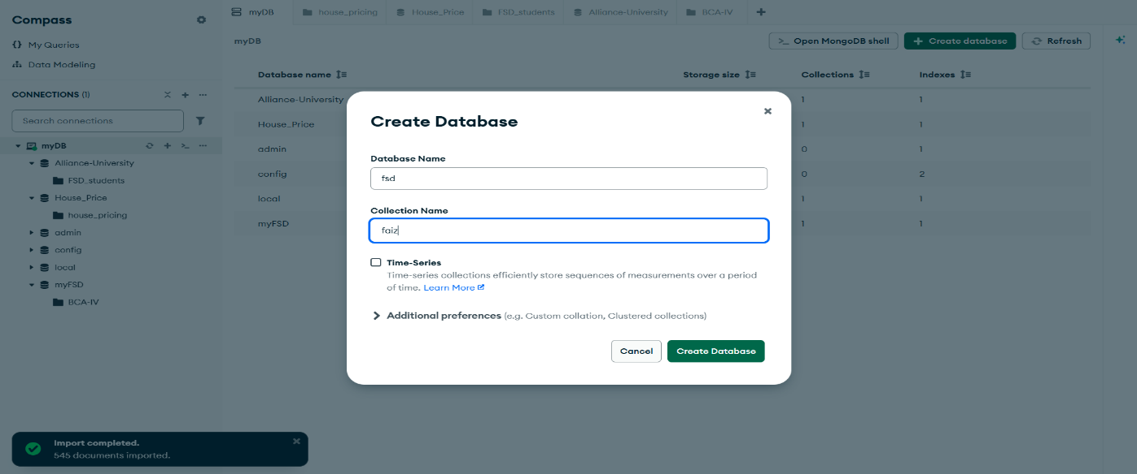
Step 2 READ :
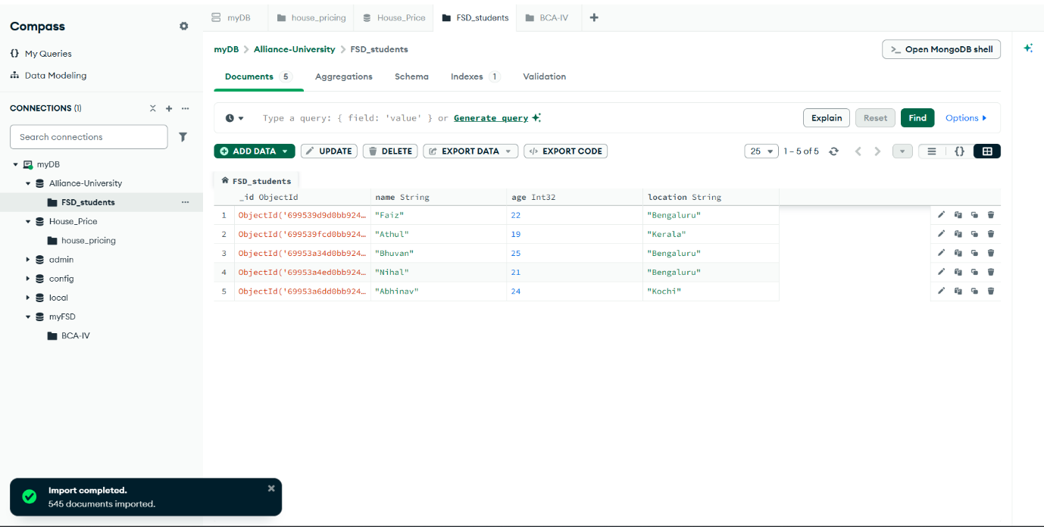
Step 3 UPDATE:
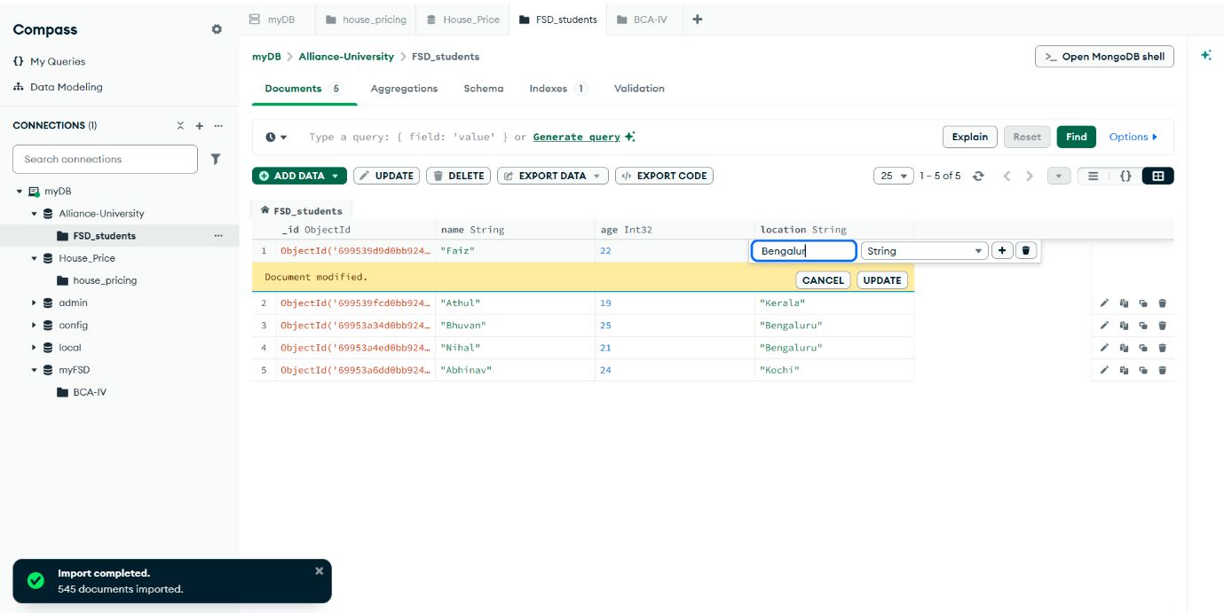
Step 4 DELETE:
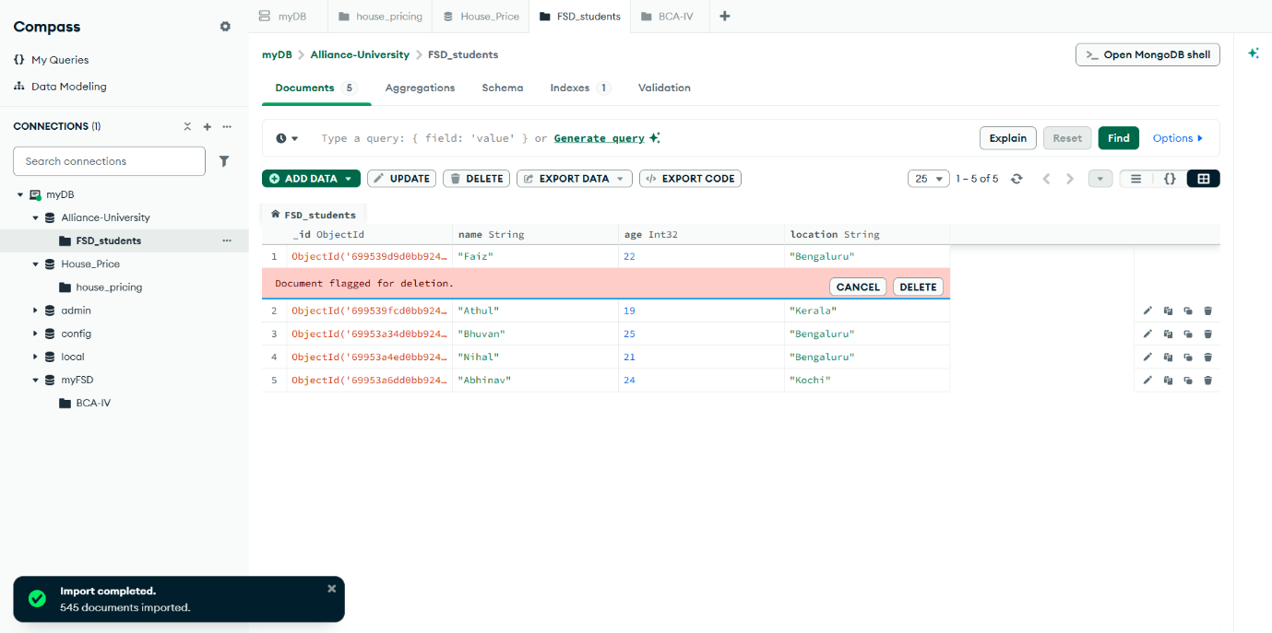

CONCLUSION
MongoDB is a powerful and flexible NoSQL database that meets modern application demands. Its document-based structure, scalability, and high availability make it suitable for large-scale and dynamic systems. By supporting fast queries, replication, and cloud integration, it simplifies data management for developers. Overall, MongoDB is an efficient solution for handling unstructured and semi-structured data in today’s rapidly evolving digital environment.

